Task Management System

Nathan Gillingham 6523

* Background to Project 2
* Identification of the end user 3
* Evidence of Analysis 3
* Description of Current System 5
* Proposed Solution Details 5
* Objectives 7
* Modelling of the Problem 8
* Acceptable Limitations 9

Background To Project

The project I am to undertake aims to create a more organised and resourceful task manager that fills gaps many other programs fail to. Features such as priority queues and complex hierarchy user systems are not included in popular programs such as Google Classroom. These limited capabilities mean businesses are not suited to using existing task managers, as current hierarchy systems only allow for closed groups that suit a school system, not a business with a completely different structure. Furthermore, the inability to weight tasks means many can be distracted and overwhelmed with many small tasks while important, large tasks are buried and the user underdelivers. Weighting in a priority queue promises to fix this problem by properly showing which tasks should be undertaken first and the most time is given, but no such feature is evident in existing projects.

Large parts of the project will be built in WinForms as it will enable a simple but efficient GUI. The login system and actual tasks will all be built into separate databases that will be eventually stored on the end-users servers; in testing, a smaller database will be used that can be stored on a hard drive.

Identification Of End User

Mitie Group PLC is a British strategic outsourcing and energy services company. It provides infrastructure consultancy, facilities management, property management, energy and healthcare services. It has a head office at The Shard in London and more than 200 smaller offices throughout the United Kingdom and Ireland. They are the end user for this project, as their current task management system is unsuitable for a linked business and can only be used independently by separate employees, so all tasks must be individually set, which is very time efficient and allows for mistakes in the specification in tasks, as opposed to one centrally set task to multiple workers.

Analysis:

I first conducted an interview with an employee of Mitie. This will allow me to focus directly on the needs of the user. The manuscript is below and can also be found as a separate document.

Interview – Thursday 8th September 2022:

Nathan: What are the faults with your current task management system used within the company?

Jon: The current system lacks several key features such as the ability to set priority tasks, this severely diminishes productivity as it makes it harder to sort by what tasks must be done sooner. This can cause several tasks to be missed out or to be done too early which can cause further changes to the schedule. This situation is further worsened by the fact that there is no proper calendar provided, this adds to the complexity of managing when tasks must be done.

Nathan: For implementing priority, should this figure be set by the person assigning others the task, or by individuals?

Jon: I would largely prefer for the priority of tasks to be set by management as this would mean that the whole team would be on the same page as to what needs to be done. This will largely streamline the work as it will ensure that everyone is working on the same task.

Nathan: Regarding the calendar, should this display tasks set for individuals or just company-wide events?

Jon: From the tasks set by management, I would prefer to be able to choose which ones I focus on. The ones I choose should have the option to appear on my calendar or not, this would avoid the calendar from becoming too cluttered.

Nathan: How many tasks on average can you get in a week?

Jon: Anything ranging from 5-12 depending on size so the workload can get very cluttered.

Nathan: How should we set permissions for who can set who tasks?

Jon: Within the company, there is a hierarchy, people that are more important such as project managers can set tasks for their team. People should be able to set their own tasks, however, people shouldn’t have the ability to set tasks for those above them.

Nathan: Do you have an existing ID within the company for logins?

Jon: Yes, each employee is given an ID, from 0001 to 9999 which identifies them, but a password should also be in place.

Nathan: Going back to priority, how should we display which tasks need to be done first?

Jon: Nothing crazy, I think listing is probably best, maybe colour coding the most important task but that’s not a necessity.

Nathan: Okay I think that’s it, thanks.

Jon: No problem

End

The main feedback of the interview can be condensed down to:

* Integrated calendar
* Hierarchy system for setting tasks
* Being able to self-set tasks
* Build on the existing ID system for a login system.
* An ordered list of tasks based on their priority
* A GUI that avoids clutter

I will use these to form my objectives for the project as a whole and will need to consider how these will be implemented considering limitations due to time, and coding ability.

Description of Current System:

Mitie currently uses a task management system completely independently of any internal infrastructure or intranet. This means each user must set all their own tasks and manage them independently. The most important objective is to connect all users so tasks may be shared.

The software also doesn’t use any type of calendar for visual representation so this must also be amended.

It is clear the current software does not use priority for a listing of tasks, and so further research has shown this is desired by the employees.

Other Solutions:

The best example of a task manager that already exists, I believe, is Google Classroom. Whilst some features would not work for my project, or some are missing, Google Classroom is a good example to follow.

One great feature is the ability of one person to set a task to multiple people easily. This is done in the form of a classroom, where there are people with permission to set tasks and those who are in the classroom receive them. Whilst I require a more complicated hierarchy system, the concept is there and all that needs to be added is different levels of permissions.

Example of the classroom.

Another feature in Google Classroom that is included in the user requirements is the integrated calendar. It allows you to flick through different days, select or unselect assignments from different classrooms, and shows them by time. Whilst I don’t think I will be able to design a comparable GUI in terms of aesthetics if I am able to capture similar capabilities for my own project, then all user requirements in this area will be met.

Example of the integrated calendar.

Features that google classroom does not include, are the ability to set yourself tasks, and the ordering of tasks based on priority. Tasks are ordered purely by the due date, but this is not always helpful as people can get distracted by small tasks and are unable to dedicate time to important tasks, as detailed in the interview.

Using the interview and research on already completed projects, I have completed an objective list, which also includes details on how I will try to code each component, as this will give me a better starting point when executing project plans.

Objectives:

1. Maintain a database of employees, tasks, groups, and roles

* Use DDL to create multiple tables to contain all database entries in normal form.
* Use DDL to create relationships between tables to link certain entities.
* Create a WinForms UI to add and delete entries from each database.
* Test database integrity by addition and deletion of test entries before reaching the client.

1. Establish a hierarchy system of employees and employers to allow tasks to be assigned to workers

* Use DDL to create an access level attribute based on the employee’s level within the company.
* Link this attribute to the assignment of tasks to other employees.
* Implement a checker to query the database for the two employees’ access levels.
* Use this to allow or deny the assignment of tasks between employees (tasks can only be given to those on a lower level).

1. Allow organisation of tasks based on the date due, and a given priority

* Use DDL to establish a table with Title, Description, Due date, and priority attributes.
* Use SQL queries to sort these based on the Due date, with the nearest being first.
* Create a priority queue that lists the tasks of an individual based on the date due, and then priority within the dates.
* Use WinForms to integrate this all into an employee-based GUI

1. Create an employee log-in system

* Create a hashing algorithm and use this to store hashed passwords in an indexed array, with an open addressing collision system.
* Use WinForms to create a GUI for employee login where username and password can be entered.
* Accept a mass list of logins into a database from the client so each employee account doesn’t have to be entered manually.
* Check the login against the hashed value in the corresponding database entry.
* Ensure employee attributes cannot be changed from within the account for changed access level

1. Allow tasks to be marked as completed and cleared from the calendar

* Use WinForms the create a calendar GUI that displays the tasks and dates of the employee logged in.
* These Tasks will be embedded with buttons:

                          One-click to expand the task and show its description

                          Delete the button to remove the task from the calendar and mark it as done

* Allow the employee to navigate through the calendar to any specific date and time using an SQL search embedded within the GUI
* Allow the employee to create their own personal tasks added only onto their calendar, again using embedded SQL methods.

Modelling

Modelling is a visual representation of problems and their associated solutions and can be easier to understand than written forms in many cases. In my project, one problem that can be well represented is the hierarchy system of users.

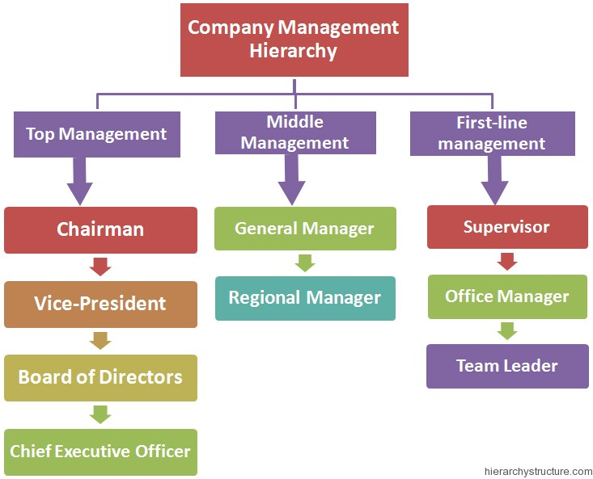

Shown is a flow diagram of the tiers of employees within the company. One way the hierarchy system could work is the rows being given different permissions. If the end users feel this is too restrictive, as perhaps a supervisor would have the same permissions as an Office manager, then each job role can be divided individually so that no two job roles exist as the same, unless this is desired for specific roles that sit on the same level. An addition to the code that would be a feature of Google Classroom is the ability to create work groups separate from other staff so that one manager can isolate a group of staff and share tasks and messages with them.

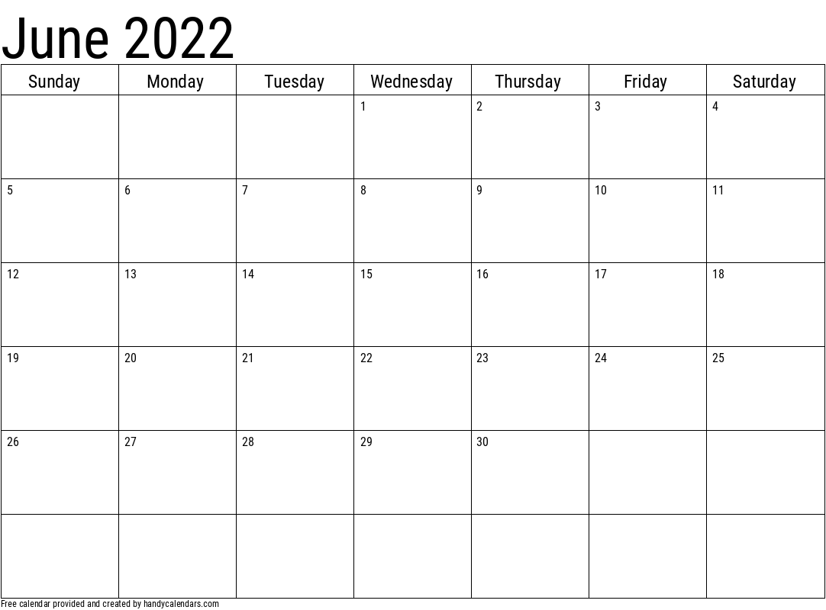Another visual feature of the project is the integrated calendar. I will keep a simple design as I believe involving complex design and colour will slow the project and add far less substance to the result than ensuring all features work properly. Within each square representing a date, the user will be able to add their own task to be shown. In addition, tasks will be chosen that can be displayed. This will ensure the most important tasks are shown whilst avoiding a display that is too busy, as requested in the brief, furthermore a simple black and white display, I believe, assists this feature to ensure there is never too much going on so that the user feels distracted or that they cannot clearly see which important tasks need to be completed and when.

Limitations

Whilst I will try to complete the project to as high a quality as possible, due to such constraints as time, there must be clear expectations, and a clear endpoint that is not aimed to be surpassed.

To create a GUI with anything more advanced than WinForms I believe would take up too much time, and whilst it would look nicer for the user, the actual back-end substance of the project would falter, so I will keep a simple GUI.

The login system will include example entries and admin roles in a database of entries, however, to create an entire list for all employees would take up an incredible amount of time and storage. Therefore, I will ensure the login system works, and then it shall be required of the user to create their associated account with their ID.

Finally, there will be no file attachment options in the project, unlike Google Classroom, and there I no way to transport the files without linking e-mails which would require access to the company intranet.

Solution Details:

Software:

The project will be built using visual studio, in C#, which will be the main software needed. WinForms being used means that this must happen on a Windows operating system.

For the analysis of the project, Office 365 will be used, however, this is not a necessity and can be done on freeware if needed.

Hardware:

To build the project on, a basic laptop will be used as Visual Studio is not intensive enough by any means to warrant a more powerful machine. The largest part of the hardware will not be required to build the project but will be required by MITIE to run it. Since the organisation is so large, the corresponding databases will be of a similar proportion. They will need to be stored on a central server system.